**Tangent Planes and Normal Lines**

Table of Contents

Two Dimensions 2

Three Dimensions 3

Angle of Inclination of a Plane 7

## Two Dimensions

For the equation $y=f(x)$, the **tangent** at the point $\left(x_{0}, y_{0}\right)$ has a slope $f^{'}\left(x_{0}\right)$, while the **normal** at the point has a slope $-\frac{1}{f^{'}\left(x_{0}\right)}$.

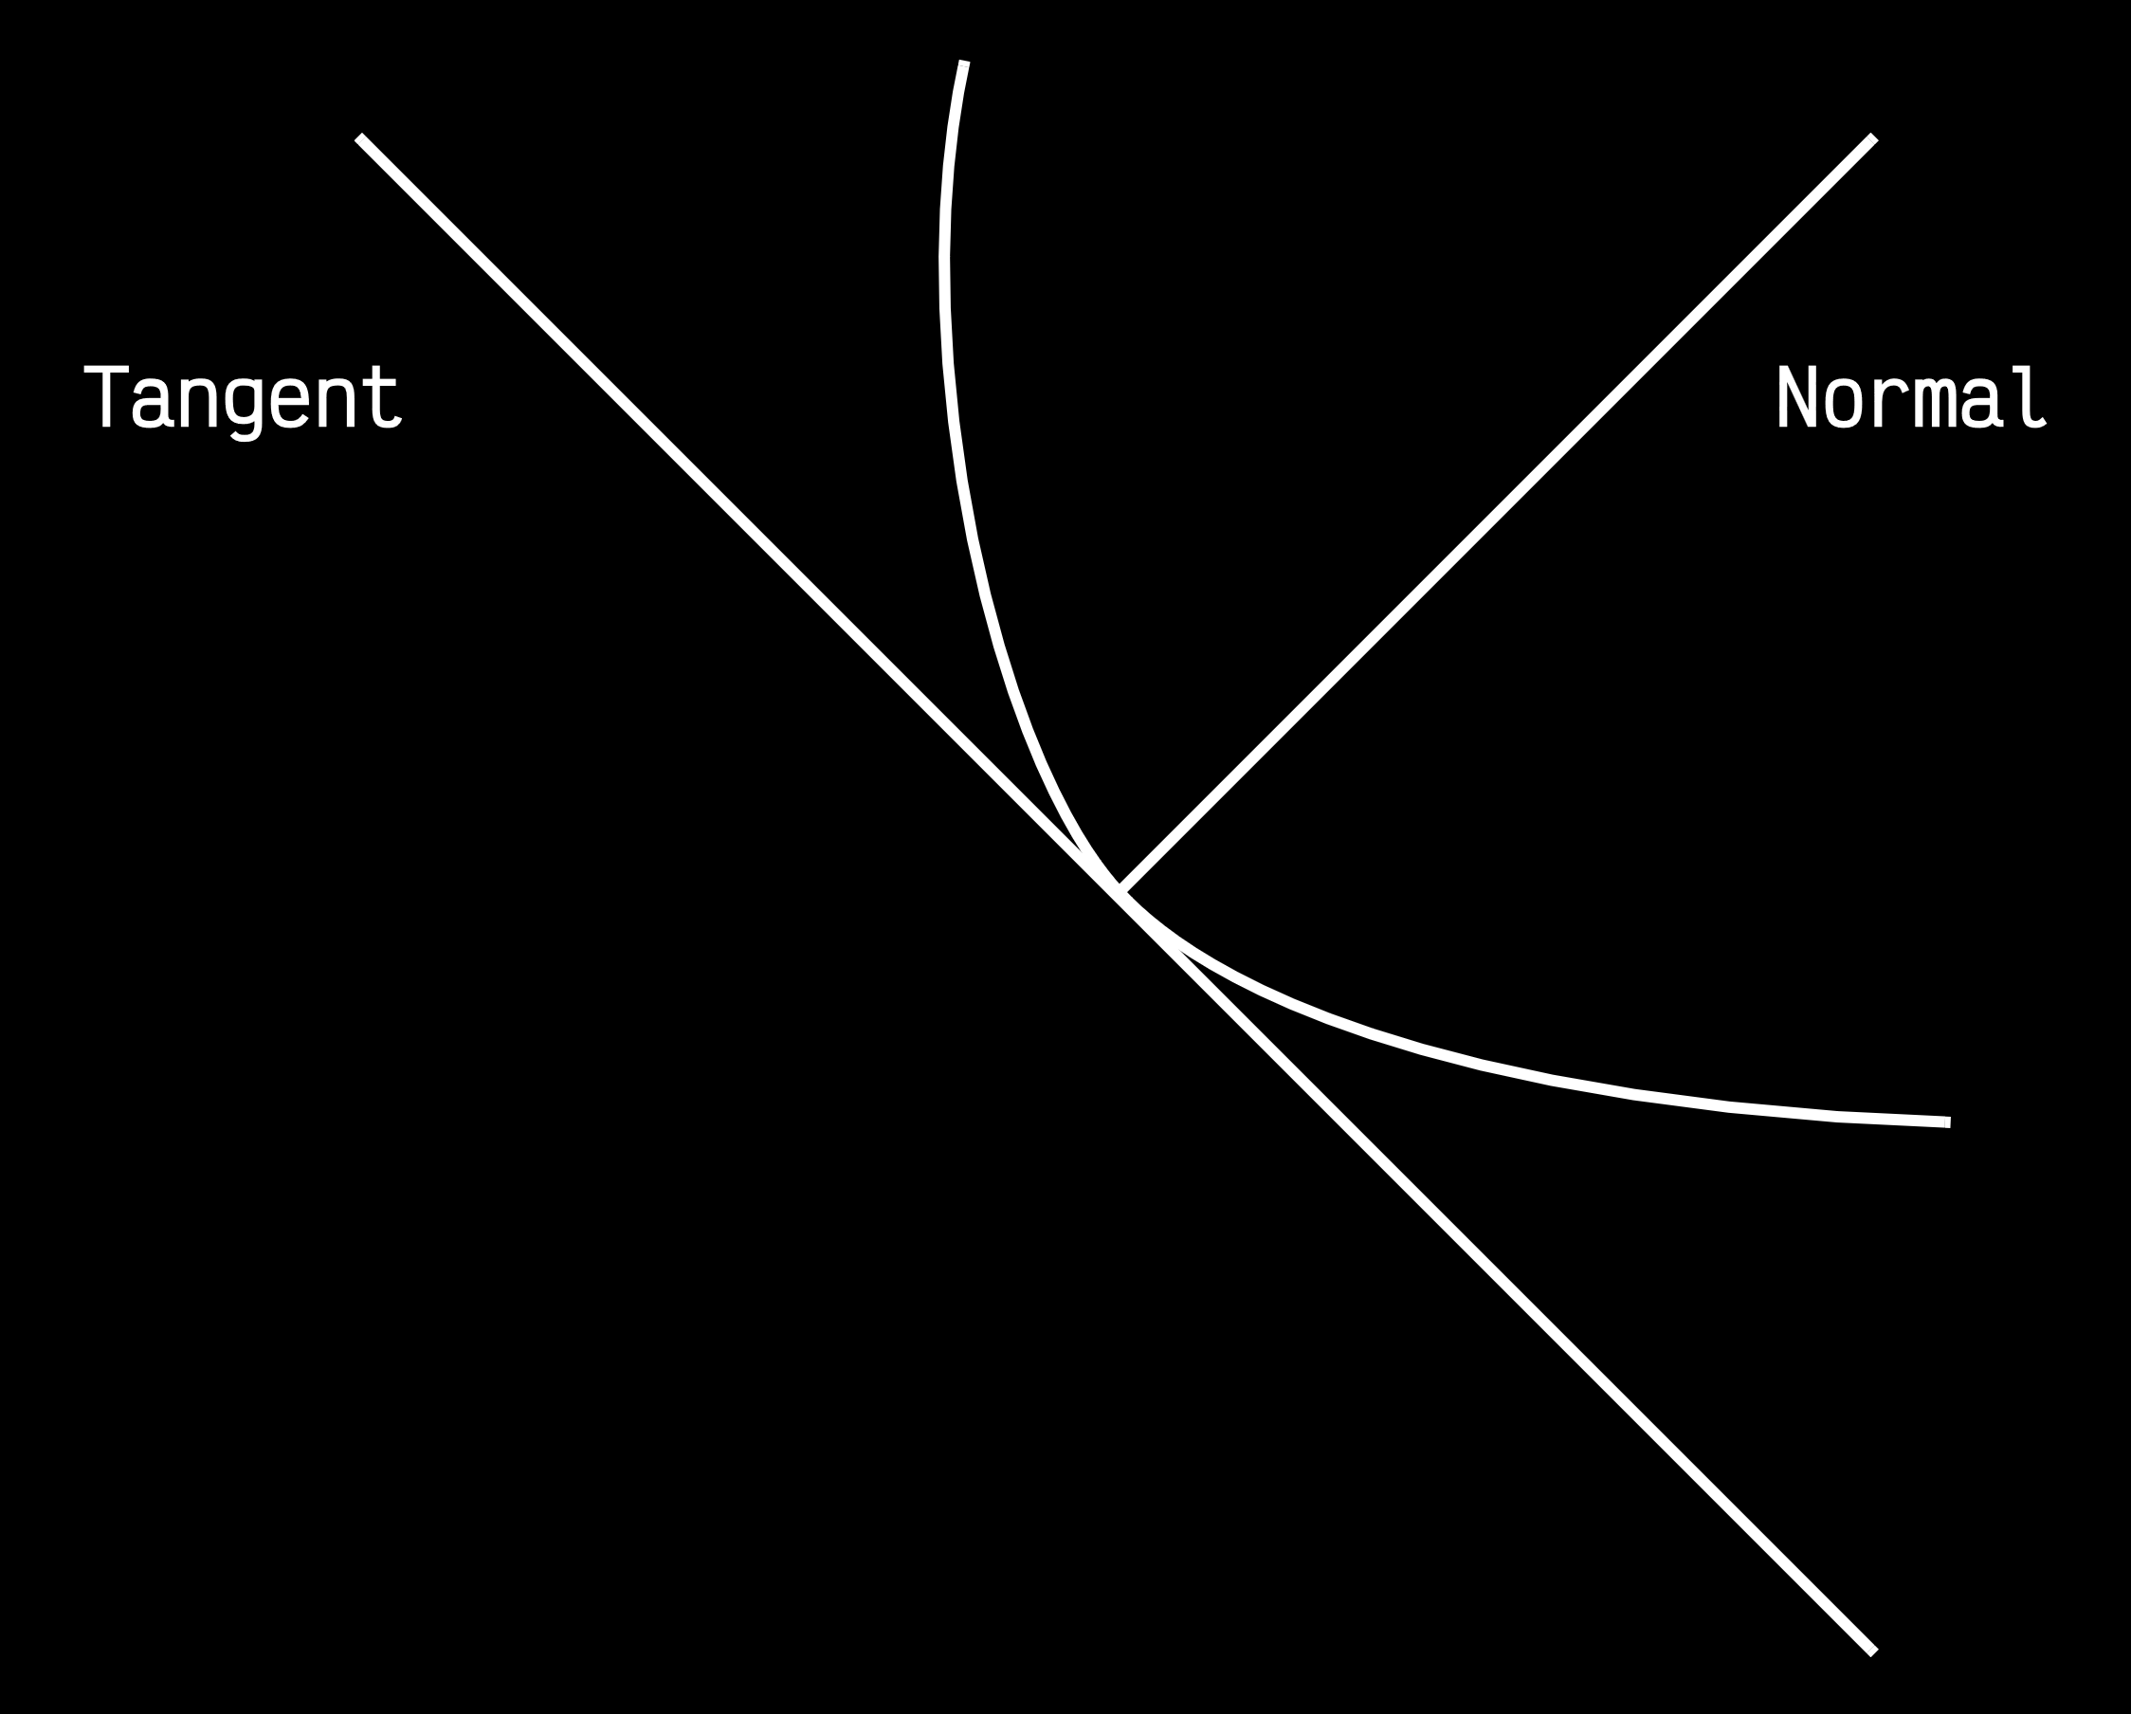

From this, we can derive that the tangent has the equation:

$$y-y_{0}=f^{'}\left(x_{0}\right)\left(x-x_{0}\right)$$

and the normal has the equation:

$$y-y_{0}=-\frac{1}{f^{'}\left(x_{0}\right)}\left(x-x_{0}\right)$$

## Three Dimensions

Normals and tangents become even more important for practical life if we move to **three dimensions**. Consider that one billiard ball is hitting another, stationary billiard ball. If the stationary ball is hit at the **point $P$**  on its surface, it will move in the direction of the **normal** at that point. The normal in this situation can also be called the **line of impact**.

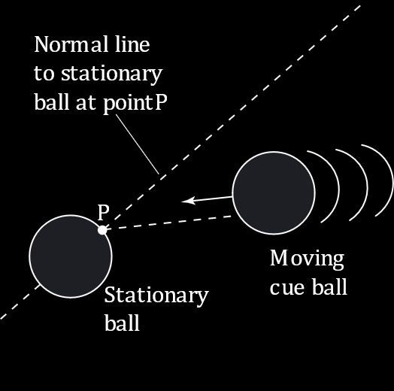

The impact can occur in two ways. One is if the **moving ball** is also moving exactly along the **line of impact**. In this case, the moving ball **stops dead** and transfers all its **momentum** to the stationary ball.

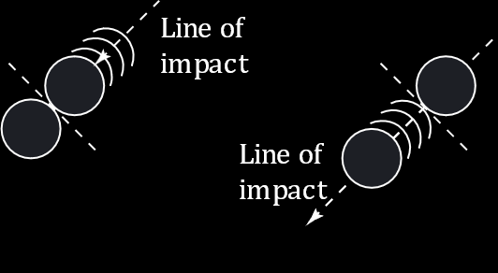

If the moving ball is not moving along the line of impact, it transfers part of its momentum to the stationary ball and gets **deflected** to one side. The direction in which it ends up moving is the **tangent** at the point $P$ of the stationary ball. Regardless, the stationary ball still moves along the line of impact.

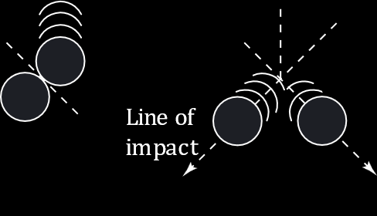

So far, we have used equations for 3 dimensions as $z=f\left(x, y\right)$. Here however, it is easier to use the format $F\left(x, y, z\right)=0$, where $F\left(x, y, z\right)=f\left(x, y\right)-z$.

Let $P\left(x_{0}, y_{0}, z_{0}\right)$ be a **point** on the **surface $S$** , defined by $F\left(x, y, z\right)=0$. At this point, we can determine $F_{x}\left(x_{0}, y_{0}, z_{0}\right)$, $F_{y}\left(x_{0}, y_{0}, z_{0}\right)$ and $F_{z}\left(x_{0}, y_{0}, z_{0}\right)$.

The next thing we need is a **direction** in which we want to determine the tangent. Let this be define as $C$, a **curve** on $S$ through $P$ that has the equation given by the **vector-valued function $r\left(t\right)=x\left(t\right)i+y\left(t\right)j+z\left(t\right)k$** . Thus, for the part of the surface that overlaps with the curve, $F\left(x\left(t\right), y\left(t\right), z\left(t\right)\right)=0$.

From the **chain rule**, we can differentiate $F\left(t\right)$ as

$$F^{'}\left(t\right)=F_{x}\left(x_{0}, y_{0}, z_{0}\right)x^{'}\left(t\right)+F_{y}\left(x_{0}, y_{0}, z_{0}\right)y^{'}\left(t\right)+F_{z}\left(x_{0}, y_{0}, z_{0}\right)z^{'}\left(t\right)=0$$

The equivalent **vector form** is

$$∇F\left(x_{0}, y_{0}, z_{0}\right)⋅r^{'}\left(t_{0}\right)=0$$

Here, $∇F\left(x_{0}, y_{0}, z_{0}\right)$ is the **gradient** and $r^{'}\left(t_{0}\right)$ is the **tangent vector**.

Since $∇F\left(x_{0}, y_{0}, z_{0}\right)⋅r^{'}\left(t_{0}\right)=0$, we can say that the **gradient** at $P$ is **orthogonal** to the **tangent vector**. This also means that all tangent lines on $S$ lie in a plane that is normal to $∇F\left(x_{0}, y_{0}, z_{0}\right)$ and contains $P$.

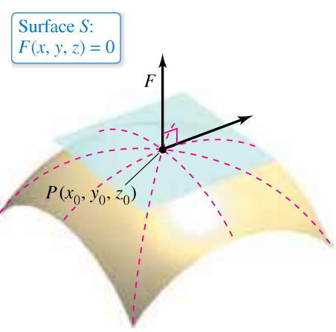

In conclusion, at a **point $P\left(x_{0}, y_{0}, z_{0}\right)$** on the **surface $S$** which has the equation $F\left(x, y, z\right)$, where $∇F\left(x_{0}, y_{0}, z_{0}\right)≠0$ and $F$ is differentiable:

* The **plane** through $P$ that is **normal** to $∇F\left(x_{0}, y_{0}, z_{0}\right)$ is the **tangent** plane to $S$ at $P$.
* The **line** through $P$ that has the **same direction** as $∇F\left(x_{0},y_{0}, z_{0}\right)$ is the **normal** line to $S$ at $P$.

If we want to determine the tangent and normal at a point $\left(x_{0}, y_{0}, z_{0}\right)$, and all we know is that $\left(x, y, z\right)$ is an **arbitrary point** in the **tangent plane**, then the equation of the vector will be

$$v=\left(x-x_{0}\right)i+\left(y-y_{0}\right)j+\left(z-z_{0}\right)k$$

Since $∇F\left(x_{0}, y_{0}, z_{0}\right)$ is normal to the tangent plane at $\left(x_{0}, y_{0}, z_{0}\right)$, it must be **orthogonal** to every vector on the tangent plane. Thus,

$$∇F\left(x_{0}, y_{0}, z_{0}\right)⋅v=0$$

This gives us another equation for the **tangent plane** to the surface given by $F\left(x, y, z\right)=0$ at $\left(x_{0}, y_{0}, z_{0}\right)$.

$$F_{x}\left(x_{0}, y_{0}, z_{0}\right)\left(x-x_{0}\right)+F_{y}\left(x_{0}, y_{0}, z_{0}\right)\left(y-y_{0}\right)+F_{z}\left(x_{0}, y_{0}, z_{0}\right)\left(z-z_{0}\right)=0$$

If we use $z=f\left(x, y\right)$, this equation becomes:

$$f_{x}\left(x_{0}, y_{0}\right)\left(x-x_{0}\right)+f_{y}\left(x_{0}, y_{0}\right)\left(y-y_{0}\right)-\left(z-z_{0}\right)=0$$

## Angle of Inclination of a Plane

Another use of the gradient, $∇F\left(x, y, z\right)$, is to determine the **angle of inclination** of the tangent plane to a surface.

The angle of inclination is the **angle**, $θ\left(0<θ<\frac{π}{2}\right)$, between **the plane** and **the $xy$ plane**.

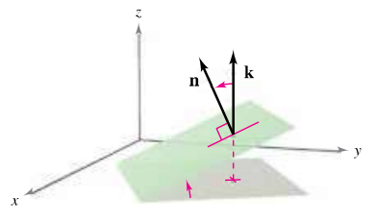

Since $k$ is the **normal to the $xy$ plane**,

$$\cos{θ}=\frac{\left|n⋅k\right|}{\left|\left|n\right|\right|\left|\left|k\right|\right|}=\frac{\left|n⋅k\right|}{\left|\left|n\right|\right|}$$

where $n$ is the **normal to the plane**.

Example

Say $\frac{x^{2}}{12}+\frac{y^{2}}{12}+\frac{z^{2}}{3}=1$ and we want to find the angle of inclination at the point $\left(2, 2, 1\right)$.

$$F\left(x, y, z\right)=\frac{x^{2}}{12}+\frac{y^{2}}{12}+\frac{z^{2}}{3}-1=0$$

$$∇F\left(x, y, z\right)=\frac{x}{6}i+\frac{y}{6}j+\frac{2z}{3}k$$

$$∇F\left(2, 2, 1\right)=\frac{1}{3}i+\frac{1}{3}j+\frac{2}{3}k$$

$$\cos{θ}=\frac{\left|∇F\left(2, 2, 1\right)⋅k\right|}{\left|\left|∇F\left(2, 2, 1\right)\right|\right|}=\frac{\frac{2}{3}}{\sqrt{{\left(\frac{1}{3}\right)}^{2}+{\left(\frac{1}{3}\right)}^{2}+{\left(\frac{2}{3}\right)}^{2}}}$$

$$θ=35.3°$$